SAP Accelerators – Qlik SaaS

Installation and Configuration

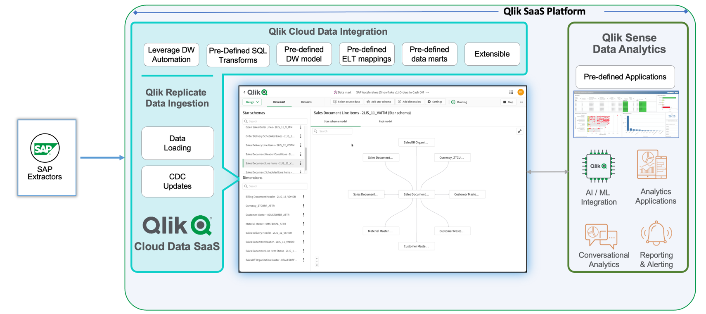

Table of Contents

Prerequisites / Assumptions 2

List of relevant Extractors to be activated: 3

Testing SAP Standard Extractor 7

Using the SAP Extractor Endpoint in Qlik Data Gateway 8

Prerequisites 8

Install SAP Java Connectivity package 8

Setup SAP Qlik Cloud Data Integration Accelerators 9

Import SAP Qlik Cloud Data Integration Accelerators 10

Landing Tasks - SAP Qlik Cloud Data Integration Accelerators 13

Storage Tasks - SAP Qlik Cloud Data Integration Accelerators 16

Transformation Tasks - SAP Qlik Cloud Data Integration Accelerators 17

Data Mart Tasks - SAP Qlik Cloud Data Integration Accelerators 18

Understanding the Qlik Sense Accelerator Applications 19

Install the Qlik Sense Accelerator Applications 20

Configure the SAP Extract (QCDI) app.qvf 21

Configure the SAP Transform O2C (QCDI).qvf. --- Only app requires this step… 22

Configure the Qlik SAP QCDI apps 23

Create custom extractor ZTCURR_ATTR 25

# Prerequisites / Assumptions

Supported Versions

* SAP ECC 6+, SAP S/4 HANA

General Requirements / Design Notes

* The SAP Accelerators for SaaS are designed at starting point for SAP integration and creation of an end-to-end data pipeline.
* They are built against a STANDARD IDES implementation of SAP <https://erproof.com/what-is-sap-ides/>
* Data source for the analytics accelerators are the data marts created by the Qlik Cloud Data Integration SAP Accelerators tasks.

SAP Requirements

* Installed SAP ECC IDES System
* SAP GUI Access
* Access to SAP TCode: RSA3 – Extractor Enablement
* Access to SAP TCode: STMS – Transport Management System
* General knowledge of SAP nomenclature around extractor naming conventions, fact vs dimension vs text, and key SAP processes to test and validate data inside SAP.

Qlik Requirements

* Installation of Qlik Data Movement Gateway near SAP System for optimal performance.
* Installation of the SAP jco drivers (detailed later) on the gateway server.

# List of relevant Extractors[1] to be activated:

|  |  |  |  |  |  |
| --- | --- | --- | --- | --- | --- |
| **SAP Extractor** | **Full Name** | **Description** | **Full/ Delta** | **Fact/ Dim** | **Project** |
| 0AC_DOC_TYP_TEXT | Document Type - 0AC_DOC_TYP_TEXT | Document Type | Full | Dim | FI |
| 0ASSET_AFAB_ATTR | Depreciation Area Real or Derived - 0ASSET_AFAB_ATTR | Depreciation Area Real or Derived | Delta | Dim | FI |
| 0ASSET_AFAB_TEXT | Depreciation area real or derived text - 0ASSET_AFAB_TEXT | Depreciation area real or derived text | Full | Dim | FI |
| 0ASSET_ATTR | Asset Subnumber with Description - 0ASSET_ATTR | Asset Subnumber with Description | Full | Dim | FI |
| 0ASSET_ATTR_TEXT | Asset Subnumber with Description Text - 0ASSET_ATTR_TEXT | Asset Subnumber with Description Text | Full | Dim | FI |
| 0ASSET_CLAS_TEXT | Asset Class Master - 0ASSET_CLAS_TEXT | Asset Class Master | Full | Dim | FI |
| 0ASSET_MAIN_TEXT | Asset Class Text - 0ASSET_MAIN_TEXT | Asset Class Text | Full | Dim | FI |
| 0CHRT_ACCTS_ATTR | Chart of Accounts Master - 0CHRT_ACCTS_ATTR | Chart of Accounts Master | Full | Dim | FI |
| 0CHRT_ACCTS_TEXT | Chart of Accounts Text - 0CHRT_ACCTS_TEXT | Chart of Accounts Text | Full | Dim | FI |
| 0CO_AREA_ATTR | Controlling Area Master - 0CO_AREA_ATTR | Controlling Area Master | Full | Dim | FI, IM |
| 0CO_AREA_TEXT | Controlling Area Text - 0CO_AREA_TEXT | Controlling Area Text | Full | Dim | FI, IM |
| 0COMP_CODE_ATTR | Company Code Master - 0COMP_CODE_ATTR | Company Code Master | Full | Dim | FI, IM |
| 0COMP_CODE_TEXT | Company Code Text - 0COMP_CODE_TEXT | Company Code Text | Full | Dim | FI, IM |
| 0COSTCENTER_ATTR | Cost Center Master - 0COSTCENTER_ATTR | Cost Center Master | Full | Dim | FI, IM |
| 0COSTCENTER_TEXT | Cost Center Text - 0COSTCENTER_TEXT | Cost Center Text | Delta | Dim | FI, IM |
| 0COSTELMNT_ATTR | Cost Element Master - 0COSTELMNT_ATTR | Cost Element Master | Delta | Dim | FI |
| 0COSTELMNT_TEXT | Cost Element Text - 0COSTELMNT_TEXT | Cost Element Text | Delta | Dim | FI |
| 0CUSTOMER_ATTR | Customer Master - 0CUSTOMER_ATTR | Customer Master | Delta | Dim | ALL |
| 0CUSTOMER_TEXT | Customer Text - 0CUSTOMER_TEXT | Customer Text | Delta | Dim | ALL |
| 0DEPRARTYPE_TEXT | Standardization of Deprec. Area - 0DEPRARTYPE_TEXT | Standardization of Deprec. Area | Full | Dim | FI |
| 0EMPLOYEE_ATTR | Employee Master - 0EMPLOYEE_ATTR | Employee Master | Full | Dim | O2C |
| 0FI_AA_11 | Asset Accounting: Transactions - 0FI_AA_11 | Asset Accounting: Transactions | Delta | Fact | FI |
| 0FI_AA_12 | Asset Accounting: Posted Depreciations - 0FI_AA_12 | Asset Accounting: Posted Depreciations | Delta | Fact | FI |
| 0FI_AP_4 | Vendors: Line Items with Delta Extraction - 0FI_AP_4 | Vendors: Line Items with Delta Extraction | Delta | Fact | FI |
| 0FI_AR_4 | Accounts Receivable - 0FI_AR_4 | Accounts Receivable | Delta | Fact | FI, O2C |
| 0FI_GL_10 | General Ledger: Leading Ledger Balances - 0FI_GL_10 | General Ledger: Leading Ledger Balances | Delta | Fact | FI |
| 0FI_GL_14 | General Ledger (New): Line Items Leading Ledger - 0FI_GL_14 | General Ledger (New): Line Items Leading Ledger | Delta | Fact | FI |
| 0GL_ACCOUNT_ATTR | G/L Account Master - 0GL_ACCOUNT_ATTR | G/L Account Master | Delta | Dim | FI, IM |
| 0GL_ACCOUNT_TEXT | G/L Account Text - 0GL_ACCOUNT_TEXT | G/L Account Text | Full | Dim | FI, IM |
| 0MAT_PLANT_ATTR | Material Number with Plant - 0MAT_PLANT_ATTR | Material Number with Plant | Delta | Dim | IM |
| 0MATERIAL_ATTR | Material Master - 0MATERIAL_ATTR | Material Master | Delta | Dim | FI, IM |
| 0MATERIAL_TEXT | Material Text - 0MATERIAL_TEXT | Material Text | Delta | Dim | FI, IM |
| 0MATL_CAT_TEXT | Material Category - 0MATL_CAT_TEXT | Material Category | Full | Dim | FI, IM |
| 0MATL_GROUP_TEXT | Material Group - 0MATL_GROUP_TEXT | Material Group | Full | Dim | FI, IM |
| 0MATL_TYPE_TEXT | Material Type - 0MATL_TYPE_TEXT | Material Type | Full | Dim | FI, IM |
| 0MOVE_TYPE_TEXT | Movement Type - 0MOVE_TYPE_TEXT | Movement Type | Full | Dim | IM |
| 0PLANT_ATTR | Plant Master - 0PLANT_ATTR | Plant Master | Full | Dim | IM |
| 0PLANT_TEXT | Plant Text - 0PLANT_TEXT | Plant Text | Full | Dim | IM |
| 0PROFIT_CTR_ATTR | Profit Center Master - 0PROFIT_CTR_ATTR | Profit Center Master | Delta | Dim | FI, IM |
| 0PROFIT_CTR_TEXT | Profit Center Text - 0PROFIT_CTR_TEXT | Profit Center Text | Delta | Dim | FI, IM |
| 0RECIPCTRY_TEXT | Customer Country - 0RECIPCTRY_TEXT | Customer Country | Full | Dim | O2C |
| 0SALES_OFF_TEXT | Sales Office Text - 0SALES_OFF_TEXT | Sales Office Text | Full | Dim | O2C |
| 0SALESOFFICE_ORG_ATTR | Sales Office Organization Master - 0SALESOFFICE_ORG_ATTR | Sales Office Organization Master | Full | Dim | O2C |
| 0SALESORG_TEXT | Sales Organization - 0SALESORG_TEXT | Sales Organization | Full | Dim | O2C |
| 0STOCKCAT_TEXT | Stock Category - 0STOCKCAT_TEXT | Stock Category | Full | Dim | IM |
| 0STOCKTYPE_TEXT | Stock Category Text - 0STOCKTYPE_TEXT | Stock Category Text | Full | Dim | IM |
| 0STOR_LOC_TEXT | Storage Location - 0STOR_LOC_TEXT | Storage Location | Full | Dim | IM |
| 0TRANSTYPE_ATTR | Asset Transaction Type - 0TRANSTYPE_ATTR | Asset Transaction Type | Full | Dim | FI |
| 0TRANSTYPE_TEXT | Asset Transaction Type Text - 0TRANSTYPE_TEXT | Asset Transaction Type Text | Full | Dim | FI |
| 0VAL_CLASS_TEXT | Valuation Class - 0VAL_CLASS_TEXT | Valuation Class | Full | Dim | IM |
| 0VENDOR_ATTR | Vendor Master - 0VENDOR_ATTR | Vendor Master | Delta | Dim | FI, IM |
| 0VENDOR_TEXT | Vendor Text - 0VENDOR_TEXT | Vendor Text | Delta | Dim | FI, IM |
| 1_CO_PA_DS2 | COPA Custom Extractor - 1_CO_PA_DS2 | COPA Custom Extractor | Delta | Fact | FI |
| 2LIS_03_BF | Goods Movements from Inventory Management - 2LIS_03_BF | Goods Movements from Inventory Management | Delta | Fact | IM |
| 2LIS_03_UM | Inventory Revaluations - 2LIS_03_UM | Inventory Revaluations | Delta | Fact | IM |
| 2LIS_11_V_ITM | Open Sales Order Lines - 2LIS_11_V_ITM | Open Sales Order Lines | Delta | Fact | O2C |
| 2LIS_11_V_SCL | Allocation Scheduled Lines - 2LIS_11_V_SCL | Allocation Scheduled Lines | Delta | Fact | O2C |
| 2LIS_11_V_SSL | Order Delivery Scheduled Lines - 2LIS_11_V_SSL | Order Delivery Scheduled Lines | Delta | Fact | O2C |
| 2LIS_11_VAHDR | Sales Document Header - 2LIS_11_VAHDR | Sales Document Header | Delta | Fact | O2C |
| 2LIS_11_VAITM | Sales Document Line Items - 2LIS_11_VAITM | Sales Document Line Items | Delta | Fact | O2C |
| 2LIS_11_VAKON | Sales Document Header Conditions - 2LIS_11_VAKON | Sales Document Header Conditions | Delta | Fact | O2C |
| 2LIS_11_VASCL | Scheduled Line Items - 2LIS_11_VASCL | Scheduled Line Items | Delta | Fact | O2C |
| 2LIS_11_VASTH | Sales Document Header Status - 2LIS_11_VASTH | Sales Document Header Status | Delta | Fact | O2C |
| 2LIS_11_VASTI | Sales Document Line Item Status - 2LIS_11_VASTI | Sales Document Line Item Status | Delta | Fact | O2C |
| 2LIS_12_VCHDR | Sales Delivery Header - 2LIS_12_VCHDR | Sales Delivery Header | Delta | Fact | O2C |
| 2LIS_12_VCITM | Sales Delivery Line Items - 2LIS_12_VCITM | Sales Delivery Line Items | Delta | Fact | O2C |
| 2LIS_13_VDHDR | Billing Document Header - 2LIS_13_VDHDR | Billing Document Header | Delta | Fact | O2C |
| 2LIS_13_VDITM | Billing Document Line Items - 2LIS_13_VDITM | Billing Document Line Items | Delta | Fact | O2C |
| 2LIS_13_VDKON | Billing Item Conditions - 2LIS_13_VDKON | Billing Item Conditions | Delta | Fact | O2C |
| ZSP_STOCK_IND | Custom Stock Indicator - ZSP_STOCK_IND | Custom Stock Indicator | Full | Dim | IM |
| ZTCURR | Custom Currency Extractor - ZTCURR | Custom Currency Extractor | Full | Dim | ALL |

# Testing SAP Standard Extractor

* Run SAP transaction **RSA3\***

*Note: prefixing the transaction code with a ‘/n’ (/nrsa3) will take you to the appropriate screen*

* Enter or Select desired Standard Extractor, define parameters and execute (clock) or press F8 to execute the extraction
* Click on ‘ALV Grid’ to evaluate the results  
  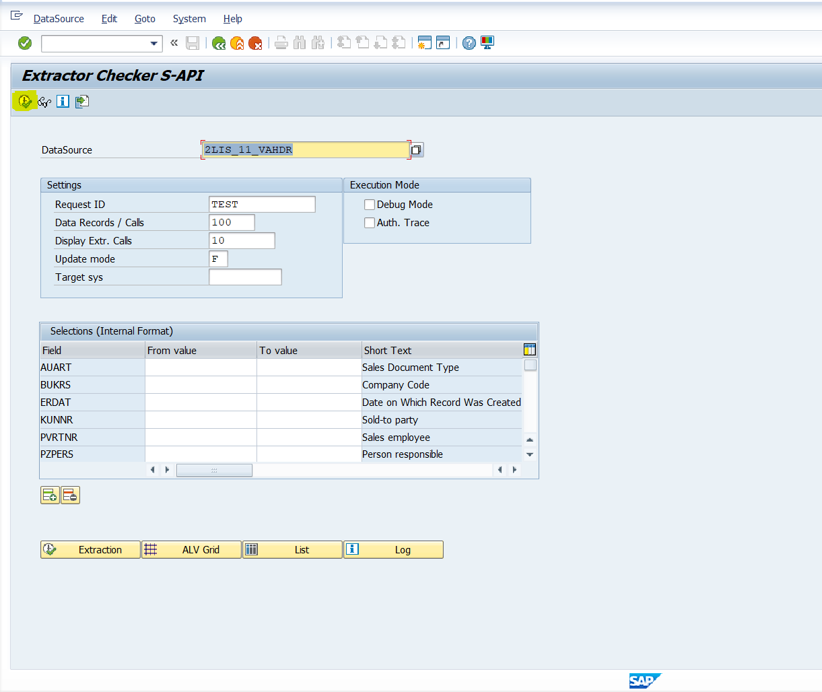  
  - Click on ‘ALV Grid’  
  - evaluate the results  
    
  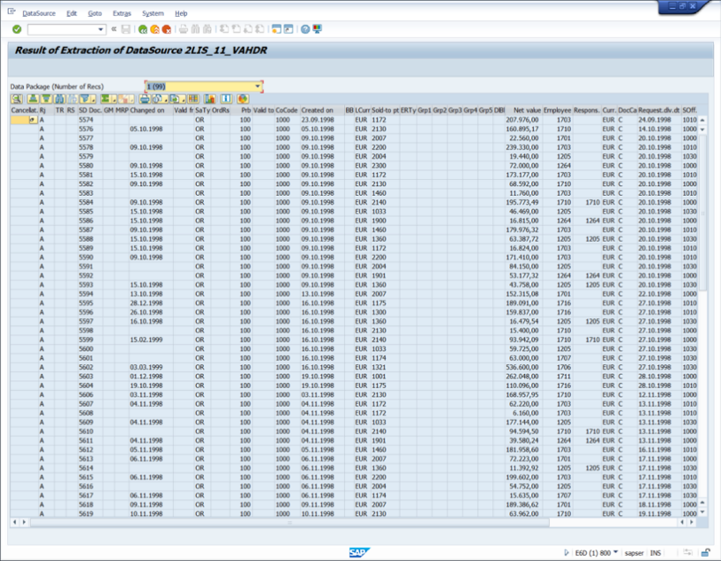

# Using the SAP Extractor Endpoint in Qlik Data Gateway

Qlik SAP Accelerators solution uses SAP Standard Extractors to extract data. Qlik Data Gateway comes with an endpoint that supports this method of extraction (SapExtractorSourceEndpoint). As this is a Java based endpoint it needs SAP Java Connectivity Package to connect to SAP on application layer basis.

# Prerequisites

* SAP System prepared according to Qlik Data Gateway User Guide (<https://help.qlik.com/en-US/cloud-services/Subsystems/Hub/Content/Sense_Hub/Gateways/dm-gateway-setting-up.htm>)
* Snowflake, Azure Synapse, Google Big Query, or Databricks as the Data Warehouse engine.
* Qlik Data Gateway installed
* SAP Standard & Custom Extractors activated
* SAP Java connectivity package (JCO) available

# Install SAP Java Connectivity package

* Download SAP JAVA Connectivity package x64_x86 for Linux from g  
  <https://support.sap.com/en/product/connectors/jco.html#section_2129803369>
* Download SAP JAVA Connectivity package x64_x86 for Windows from   
  <https://support.sap.com/en/product/connectors/jco.html#section_2129803369>
* Unzip the zip file into any directory
* Unzip sapjco3* into any directory
* Copy sapjco3.dll and sapjco3.jar to
  + /opt/qlik/gateway/movement/endpoint_srv/externals
* Restart Qlik Data Gateway

# Setup SAP Qlik Cloud Data Integration Accelerators

Confirming our data warehouse platform, we will need the correct export of the SaaS Accelerators from the Github. Currently we support:

* Azure Synapse (with ADLS bucket)
* Databricks (with S3/ADLS/GCS bucket)
* Google BigQuery (with Google Cloud Storage bucket)
* Snowflake (any cloud)

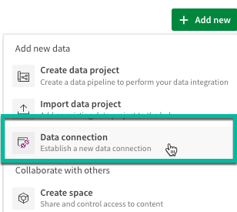

Opening up Qlik SaaS – Data Integration, we need to start by choosing/creating a Space and setting up our data connections.

These connections are specific to a Data Space – they are independent from any Analytical Spaces you may have setup in Qlik SaaS.

NOTE: To avoid confusion, there are many sources available for data integration, but for the Qlik Cloud Data Integration data warehouse project are listed above.

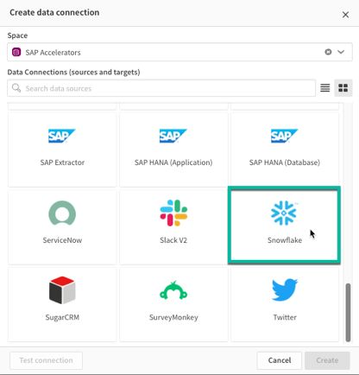

As an example, let’s use Snowflake for this example import exercise. Once we choose Snowflake, hit the create button to move to the next step.

You’ll need to enter all the credentials for the Snowflake system in this panel.

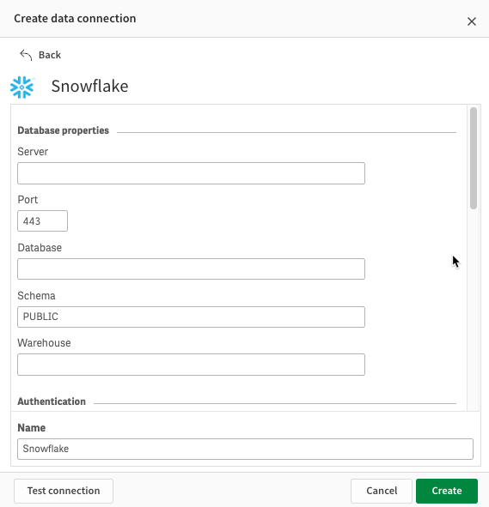 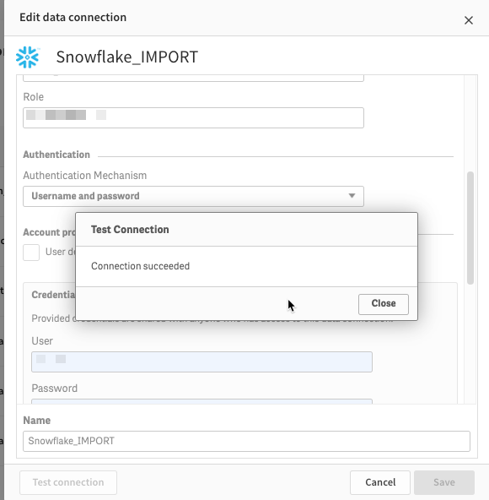

For Databricks (AWS/, Azure Synapse, and Google BigQuery, you will also need to setup a file system connection (example for AWS S3)

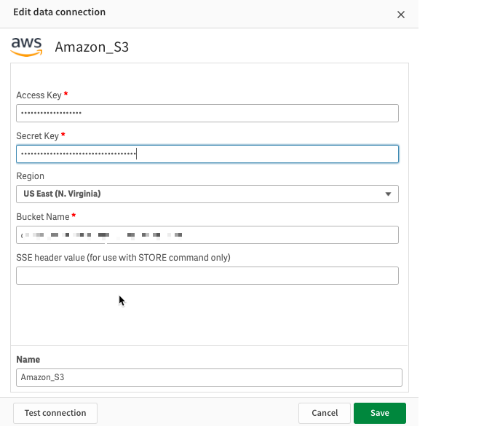

With the data connections setup, we can start the IMPORT process.

# Import SAP Qlik Cloud Data Integration Accelerators

In the space we’ve chosen, we can start the import. Select from the top left, Add New – **Import Data Project**.

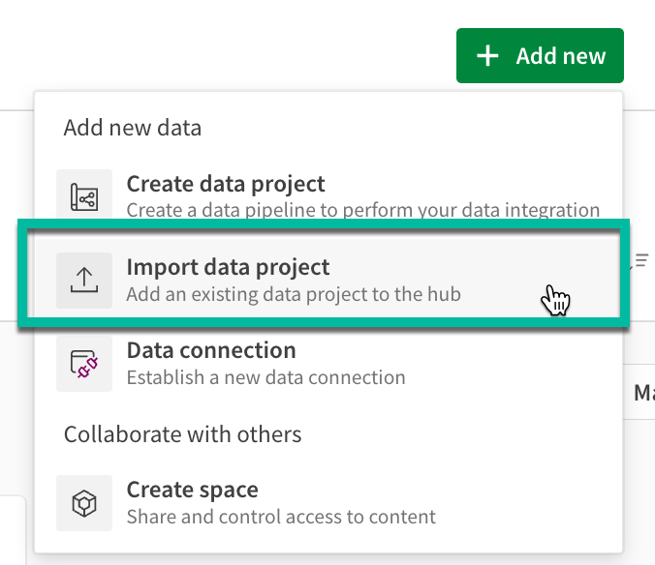 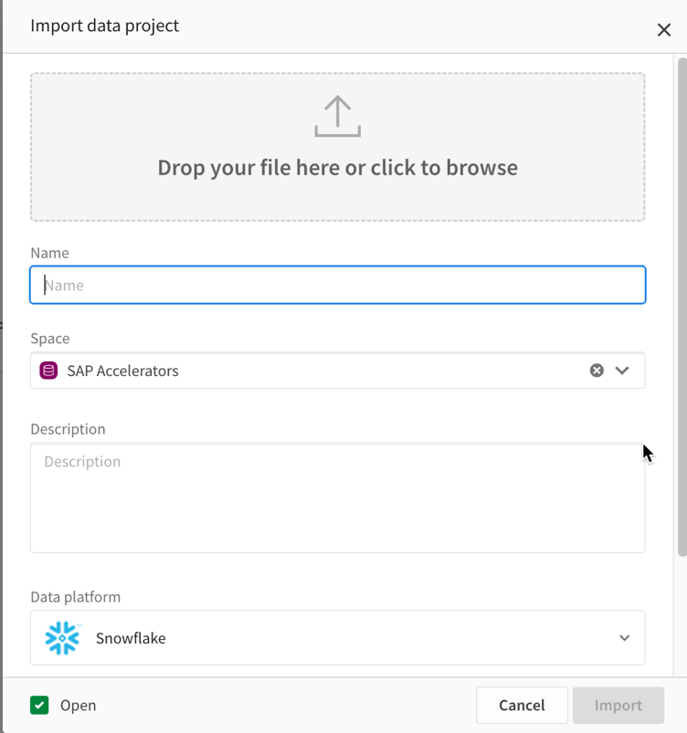

Either dragging or browsing – add the exported file from Github. NOTE: Any project will work for any data warehouse, choosing the one matched with the data warehouse engine will automatically set the project setting to that system.

For example:

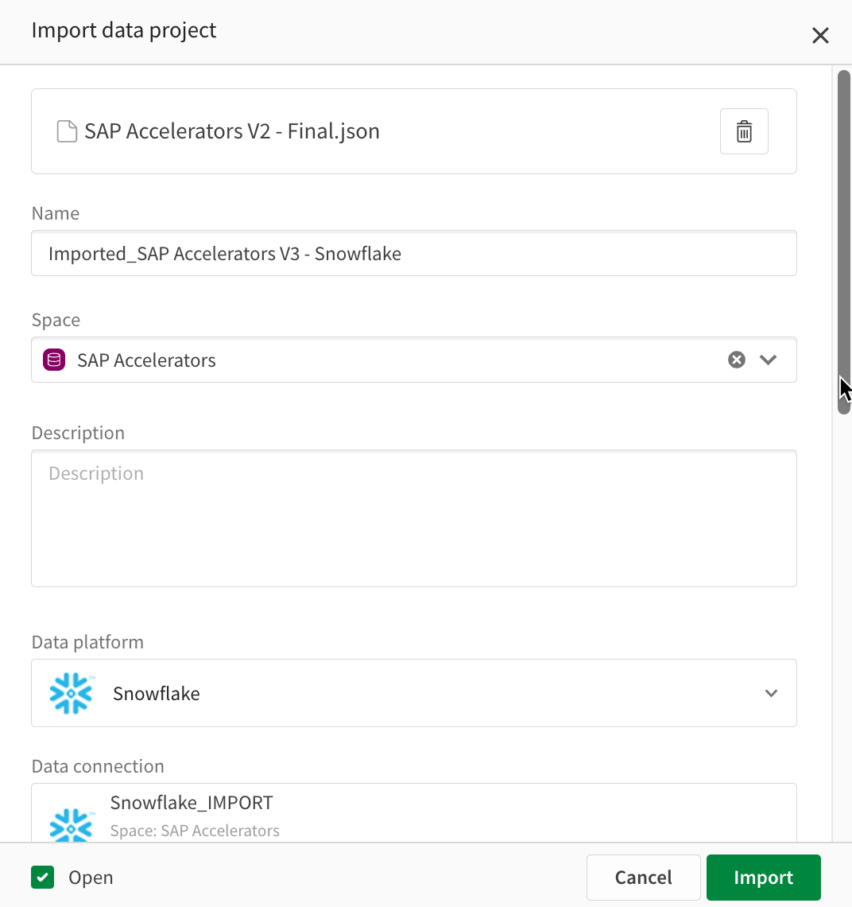 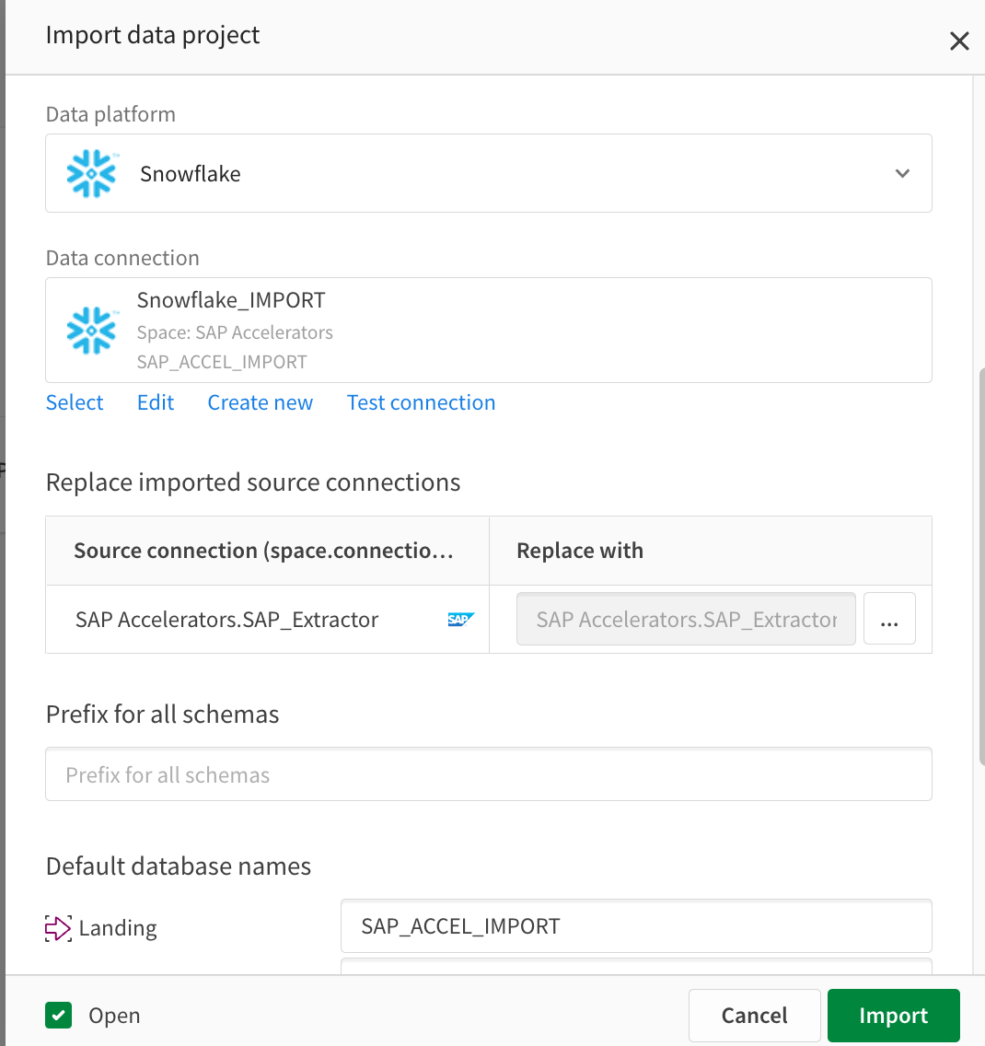

If they are not filled, choose the data connections for the correct data warehouse, and if necessary, the file system connection.

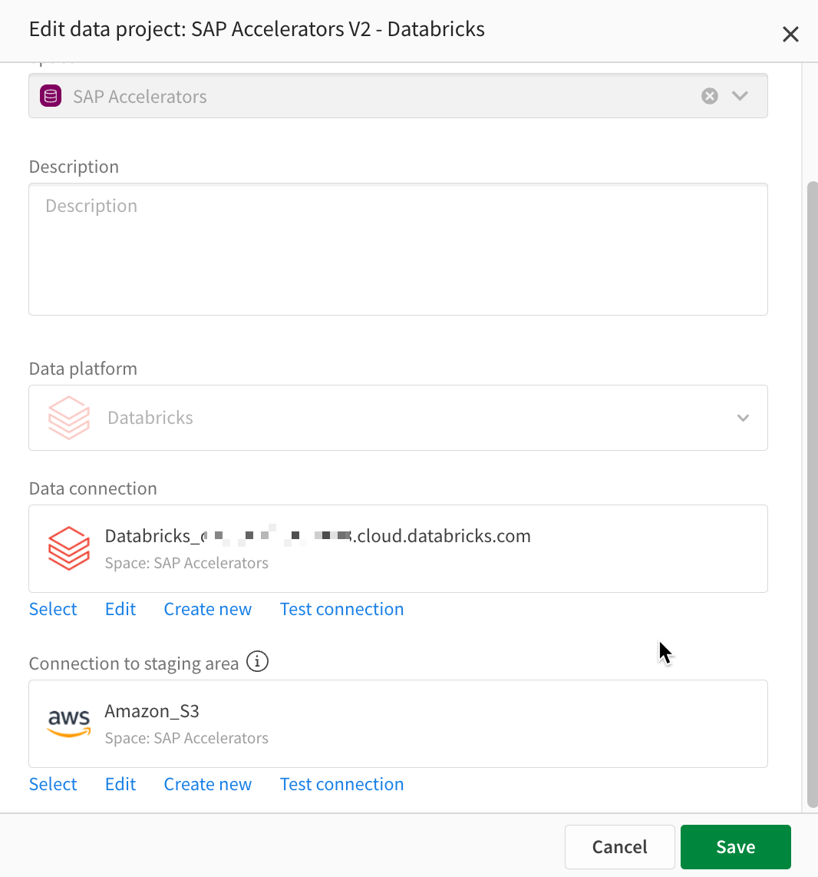

Next you will need to make sure to attach to the SAP Connection from the Qlik Data Movement Gateway.

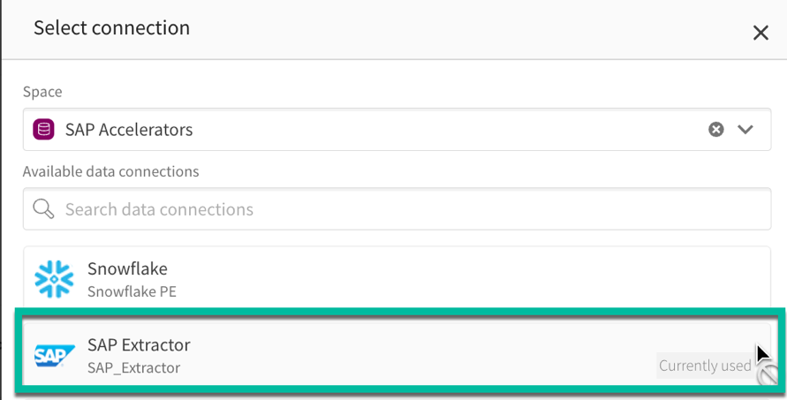

You can change the defaults for database names and add prefixes for the schemas if desired. For Snowflake, you can also alter using different Warehouses for different tasks.

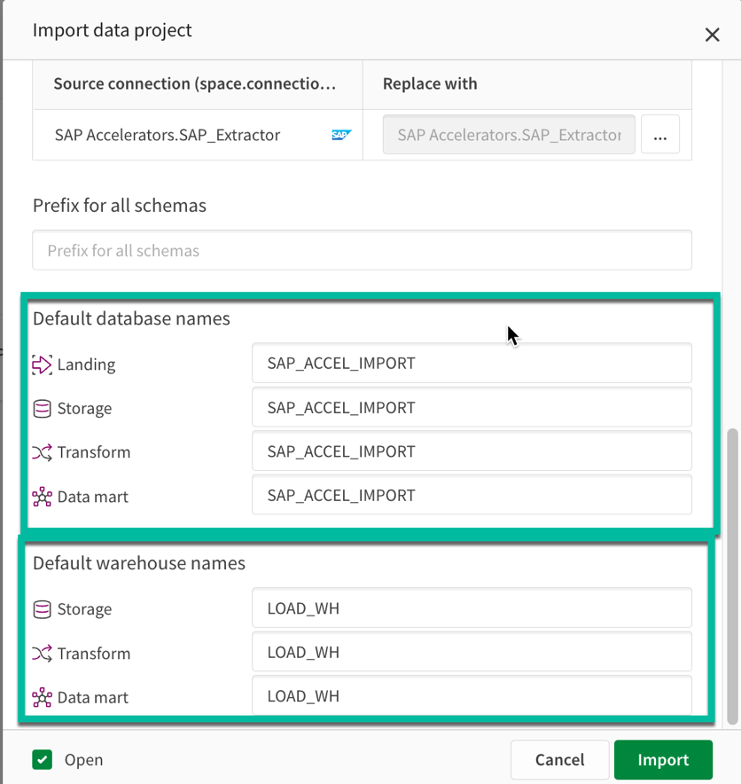

Once the settings are complete, select **IMPORT**.

The project will now open.

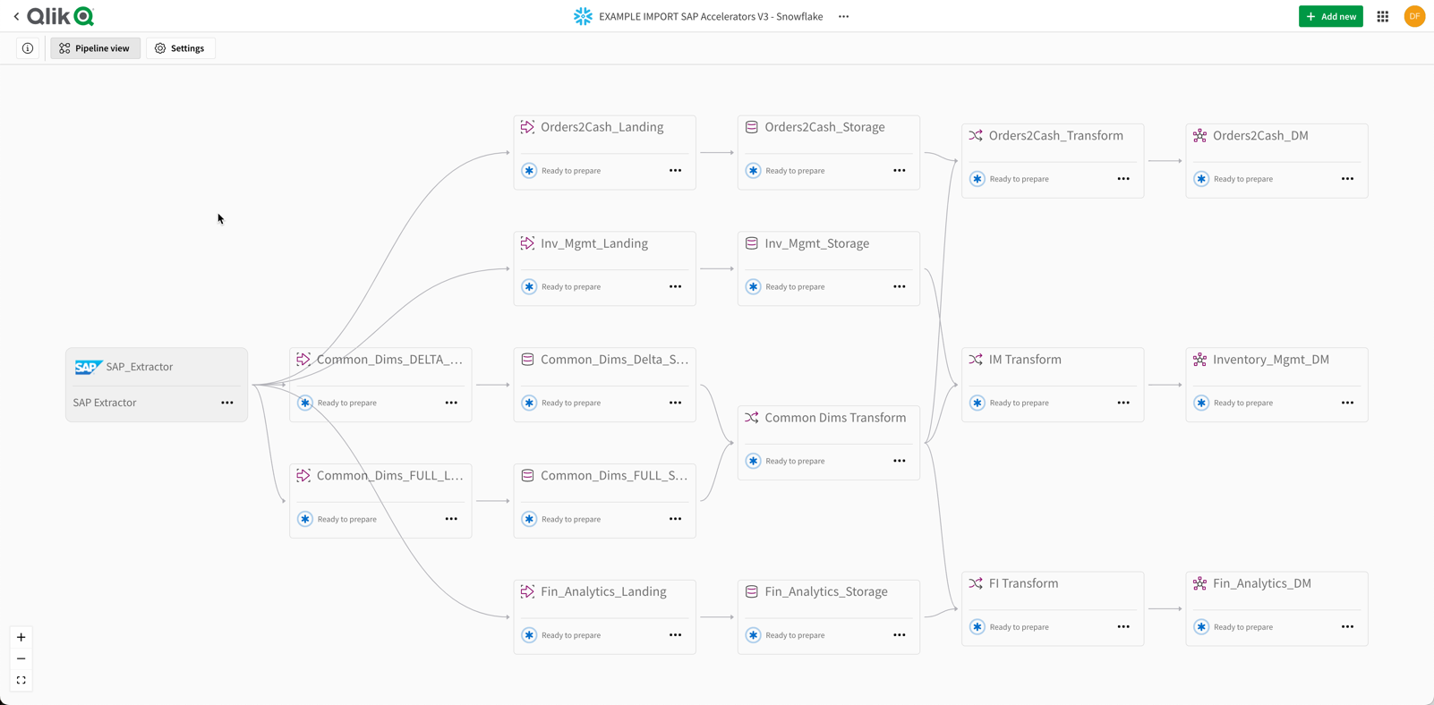

# Landing Tasks - SAP Qlik Cloud Data Integration Accelerators

Let’s now look at the process to run the Accelerators:

We will start at the LANDING layer. This is the first step where we move data from SAP into our chosen cloud database.

We start this process by running PREPARE on all the Landing tasks.

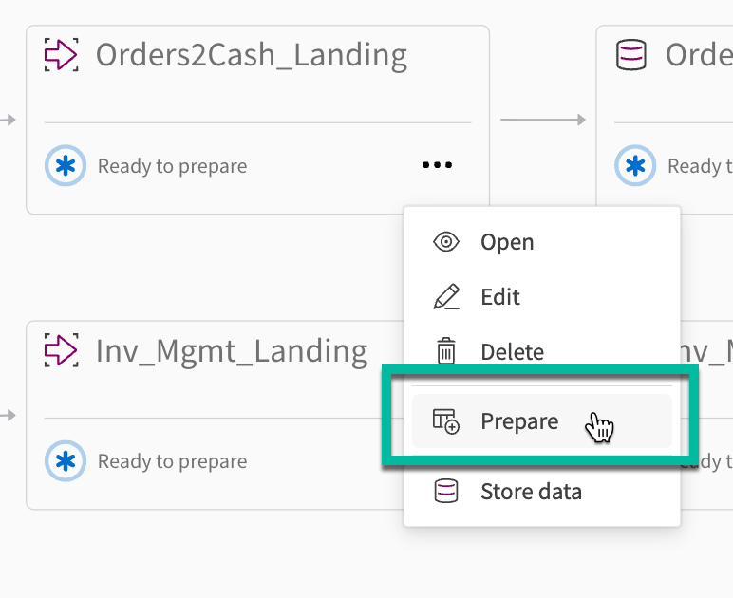

We can run all the landing **PREPARE** tasks simultaneously. This process is executing the creation of the target DDL and tables in the cloud database.

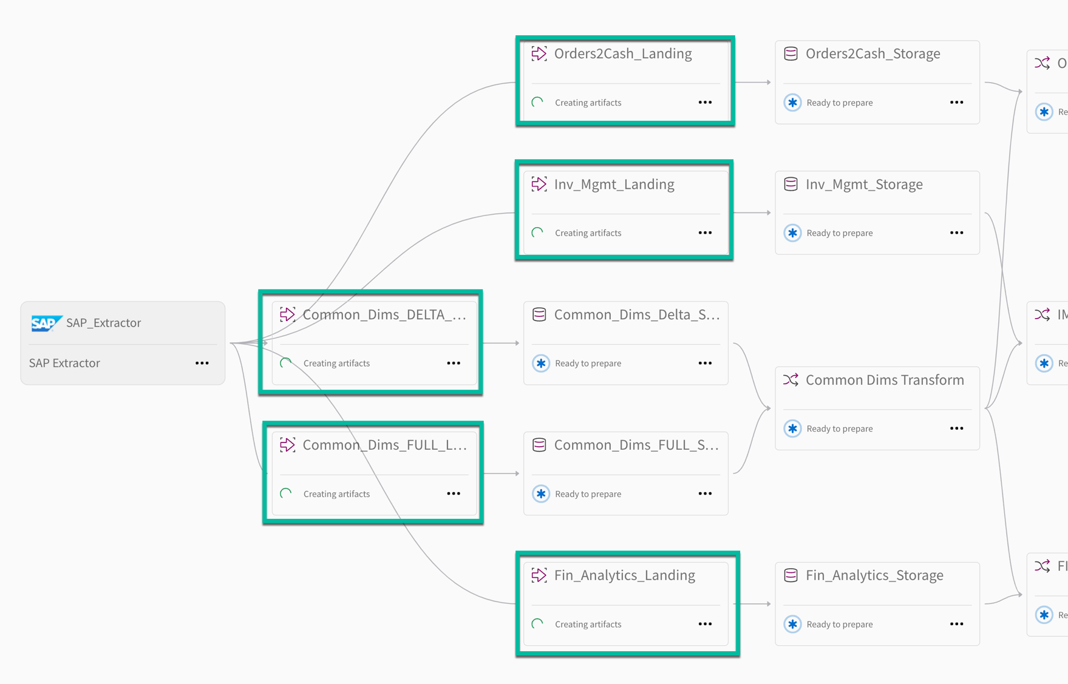

Once complete the task will show “Ready to Run”. Go ahead and **RUN** each task. This may take some time based on the size of the data and the computing power of the warehouse/database chosen. Once the base data has been loaded as the processes will move into active CDC mode automatically (except for trigger based dimensions).

# Storage Tasks - SAP Qlik Cloud Data Integration Accelerators

We now start the process of changing the columns, adding keys, and renaming from SAP shorthand to business-friendly names. This process is non-materialized and runs on top of the STORAGE layer. Much like before, we execute the PREPARE and then RUN options on the Storage layer tasks.

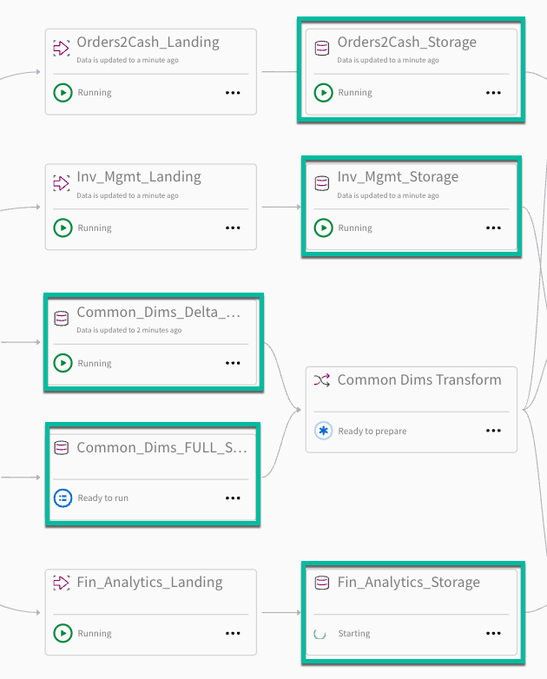

# Transformation Tasks - SAP Qlik Cloud Data Integration Accelerators

We now need to start altering the SAP data into a more analytics ready shape using ETL capabilities, as well as prepare the data for Data Mart by creating the relationships between the tables.



Much like before, we execute the PREPARE and then RUN options on the Storage layer tasks. Note – run the “**Common Dims Transform First**”

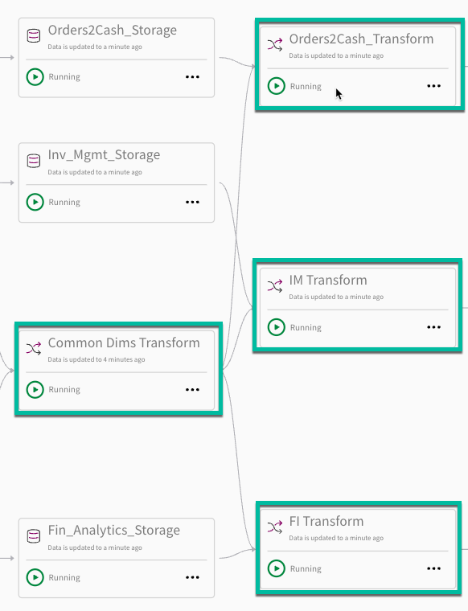

# Data Mart Tasks - SAP Qlik Cloud Data Integration Accelerators

We now need to run the final stage of deployment in Qlik Cloud Data Integration, the Data Mart tasks.



Like before, we execute the PREPARE and then RUN. Once this is complete, the SAP Accelerators for Qlik Cloud Data Integration have been deployed. The entire data preparation component of the project is now complete, and we move into the Analytics stage of the project.

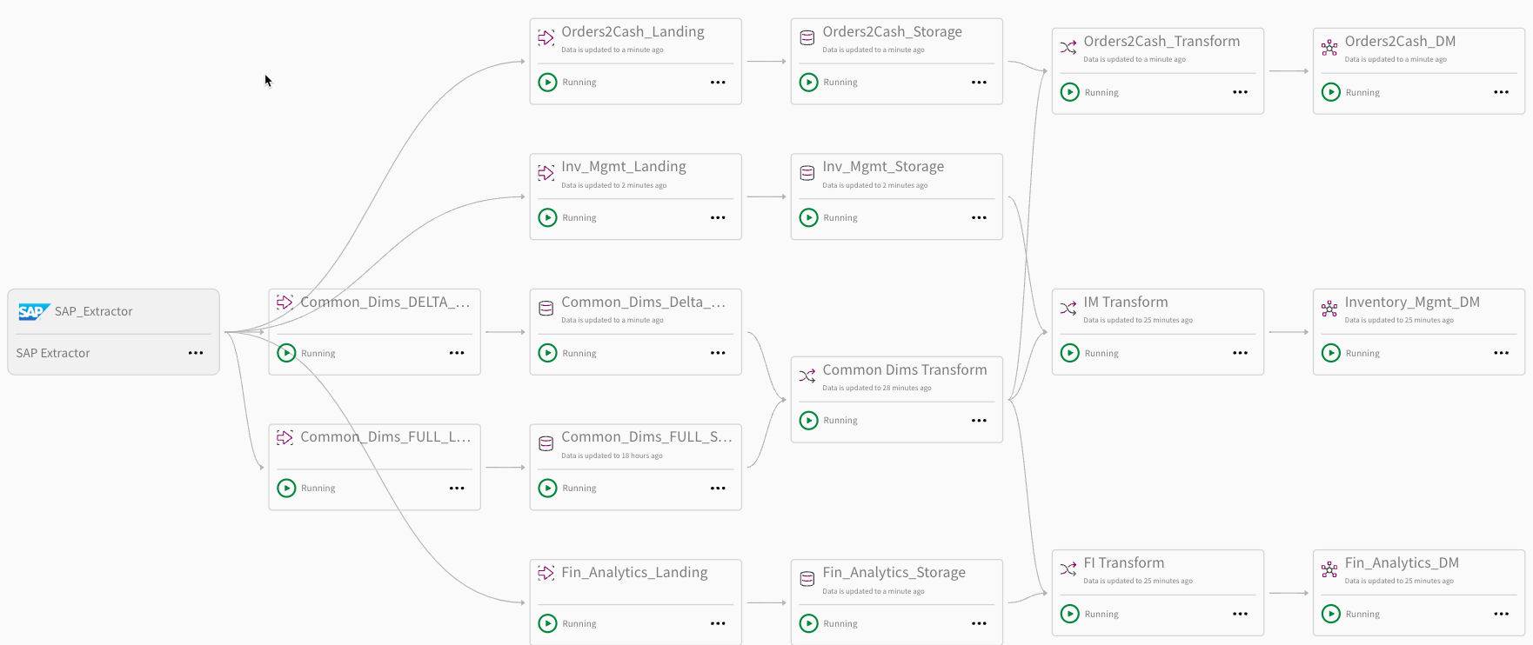

Understanding the Qlik Sense Accelerator Applications

The “SAP Extract (QCDI)” application simply loads the raw data from every table, for each of the data marts and stores it in its raw format to QVD’s.

The SAP Orders to Cash (QCDI) application loads the raw QVD’s and goes through a bunch of denormalization and aliasing steps to create a more human friendly and readily consumable Qlik data model. SAP Financial Analytics (QCDI) and SAP Inventory Management (QCDI) load directly from the base SAP QVDs.

*The question often arises “Why not just do all steps in 1 application?”*

*The answer is always “In our test environment we can’t do incremental loads because data is never changed. So, after any POC you will need to modify the process to load the batched changes incrementally, merge the data with the existing raw data, then run the “denormalization” application.*

The SAP QCDI applications load the denormalized QVD’s and construct several data island tables used for KPI’s and analysis and builds a ton of variables that can be used as needed.

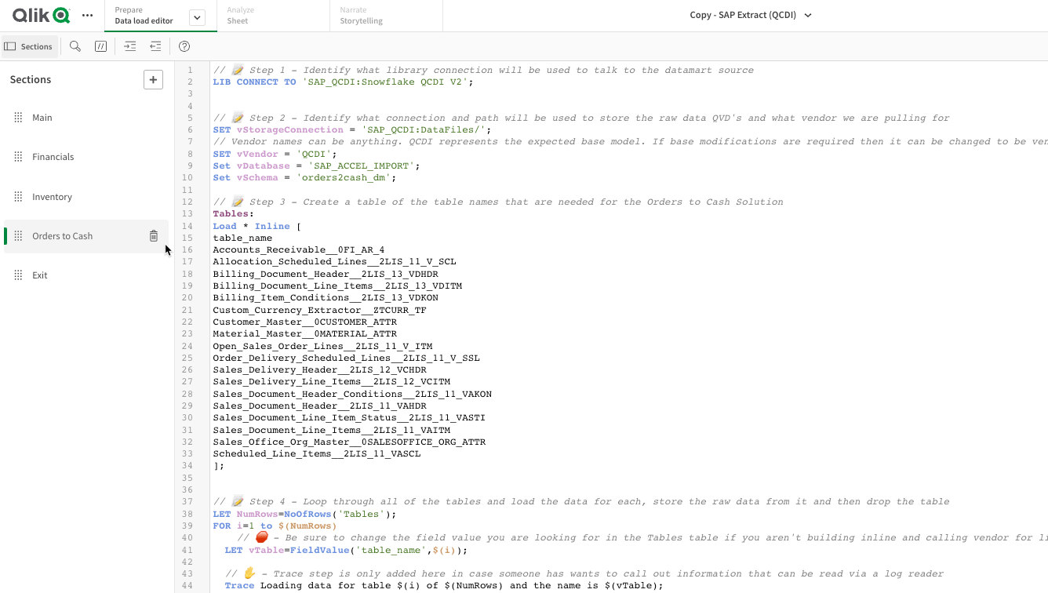

# Install the Qlik Sense Accelerator Applications

Step 1: Create a new Shared Space in the SaaS Tenant

Name the space SAP_QCDI (as an example).

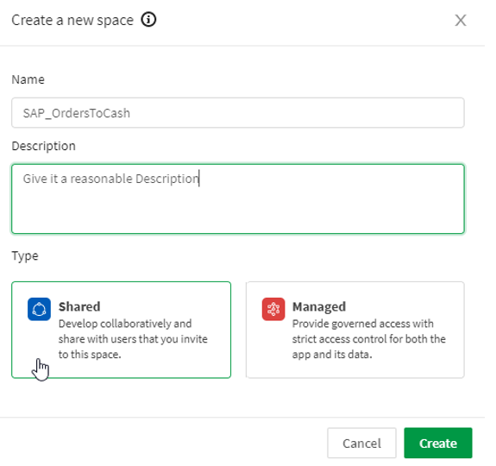

Step 2: Upload the QVF’s to the space just created .

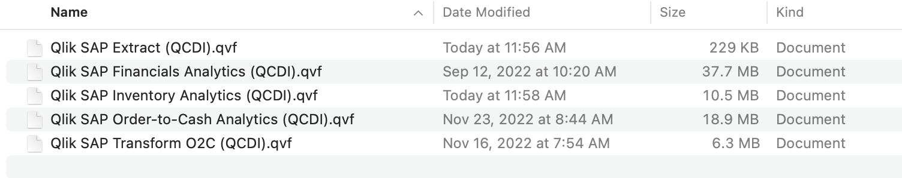

Configure the SAP Extract (QCDI) app.qvf

Step 1: Open the application and go to the load script

Step 2: Create a new Connection for your Snowflake (or appropriate) Database

Step 3: Follow the prompts within the load script and replace the LIB CONNECT TO with the appropriate connection you created and change the variables for the Database and Schema as appropriate for your environment as well as desired QVD export location. You can use the same or different spaces/directories for the QVD or keep them all in one place.

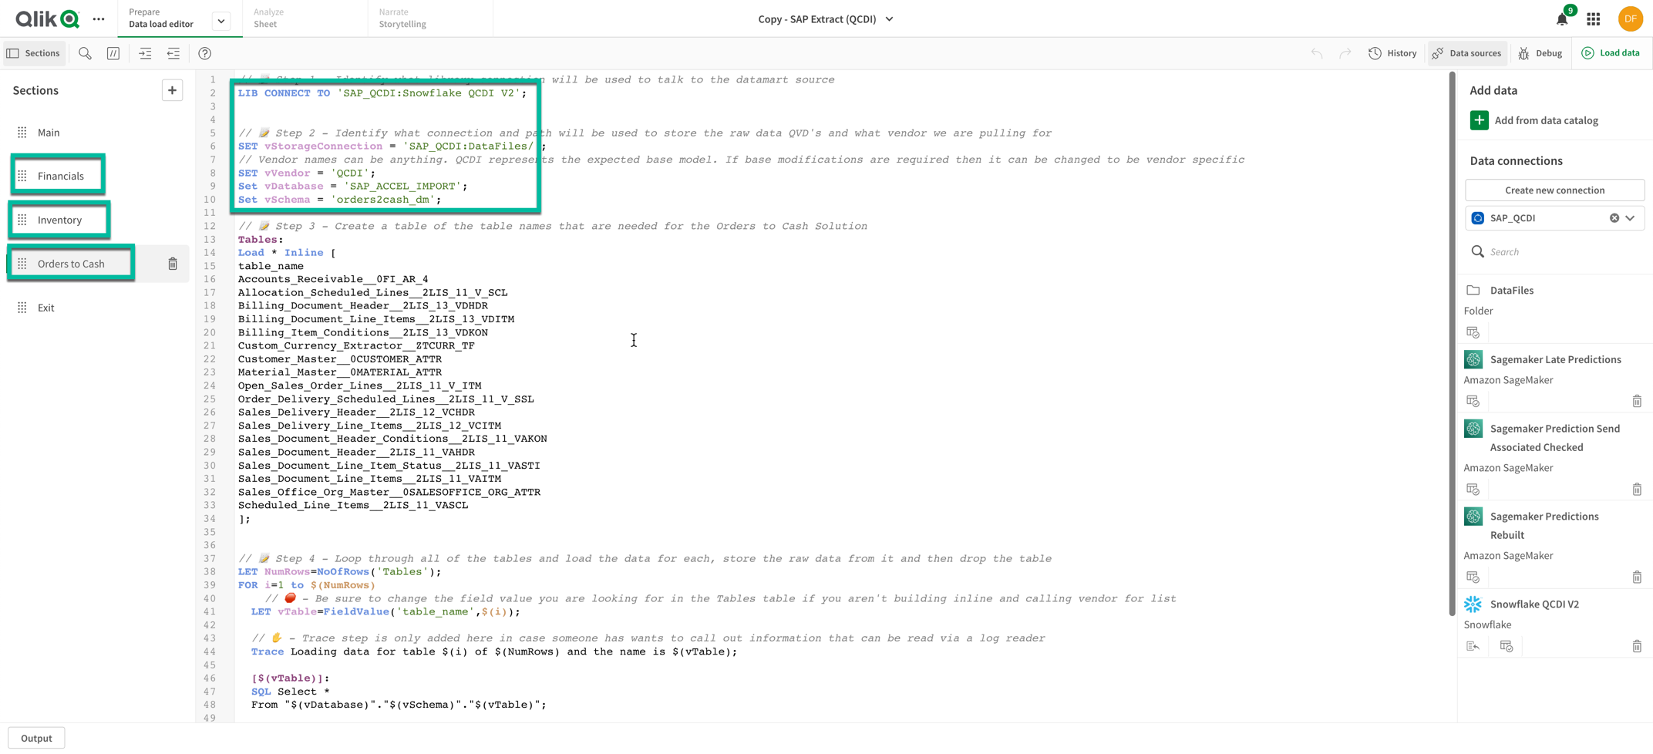

Step 4: Run the load script so that the raw data is extracted from all of the data marts from the QCDI accelerators projects.

Configure the SAP Transform O2C (QCDI).qvf. --- Only app requires this step…

Step 1: Simply set the variables for the RAW QVD file location and the location where you wish to save the denormalized QVD files.

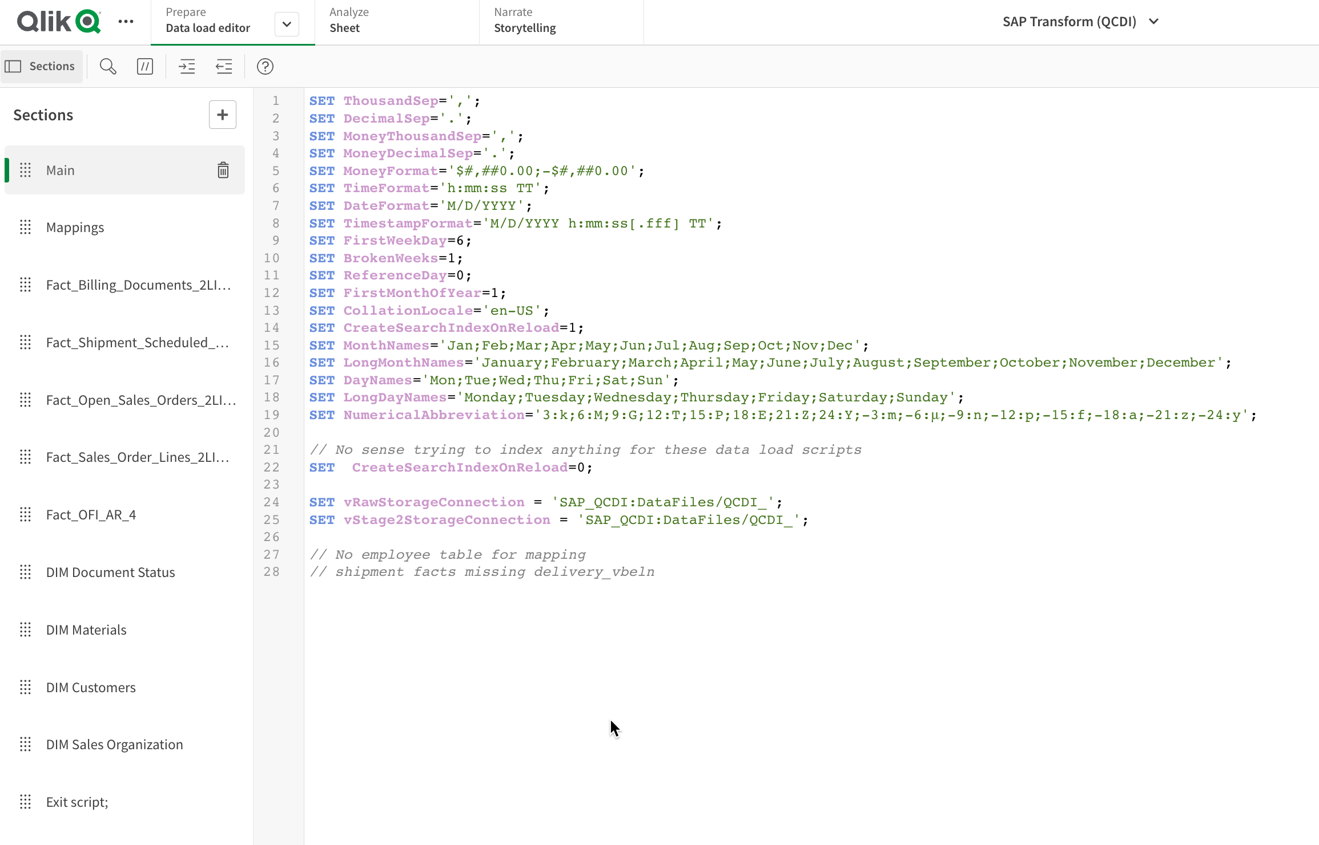

Step 2: Run the load script to generate the denormalized QVD files for Orders to Cash.

Configure the Qlik SAP QCDI apps

Step 1: Even easier than the denormalizer application all you need to do is set the location where the denormalized QVD files are located:

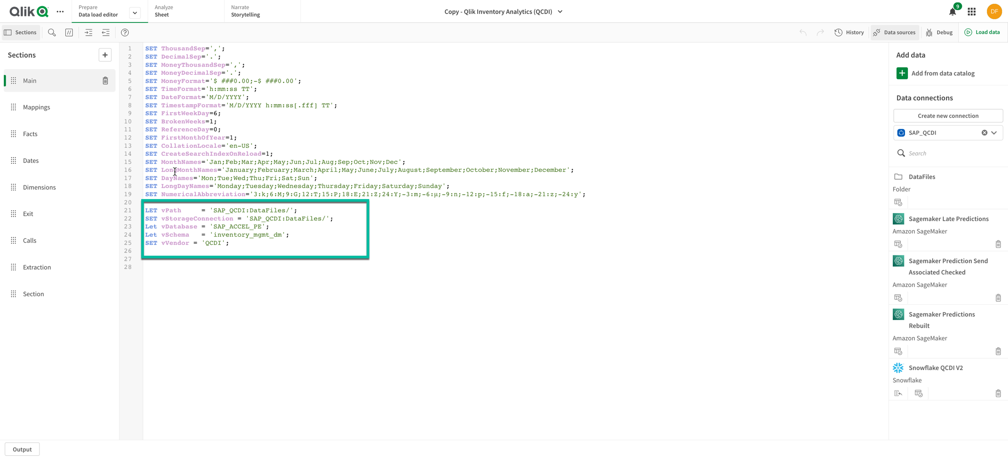

Step 2: Run the load script to read all of the denormalized QVD files and handle all of the other processing needed to prepare the application.

Step 3: Ensure that the Master Field QA screen shows that data for the tables is loaded and validate it is about the volume of data you know your data marts were populated with. [You can also use the screen to check field values and data ranges.]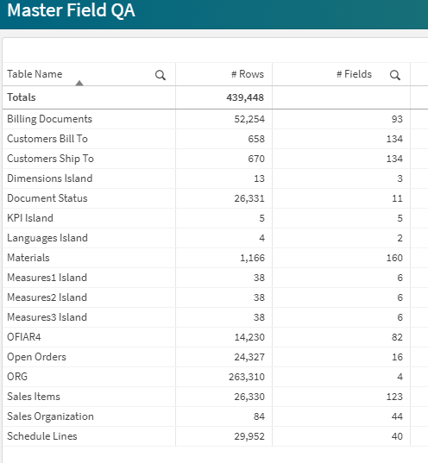

Step 4: Enjoy!

SAP Custom Extractor Appendix: ZTCURR

Introduction – Currency maintenance

Currency is maintained in SAP through

* Transaction SPRO  
  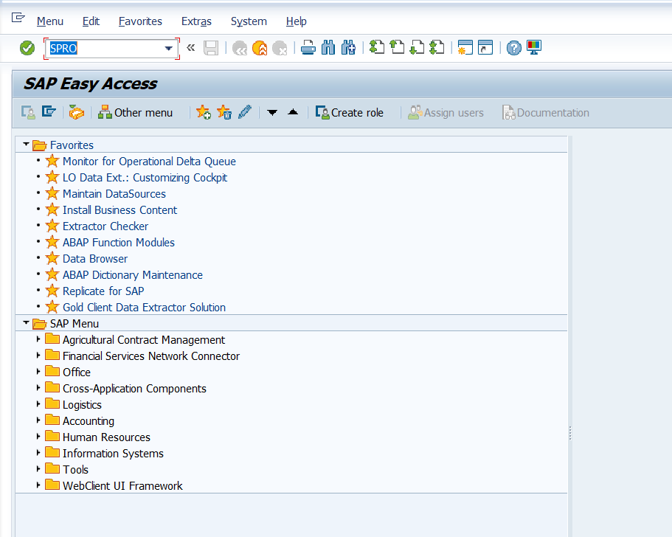
* SAP Reference IMG  
  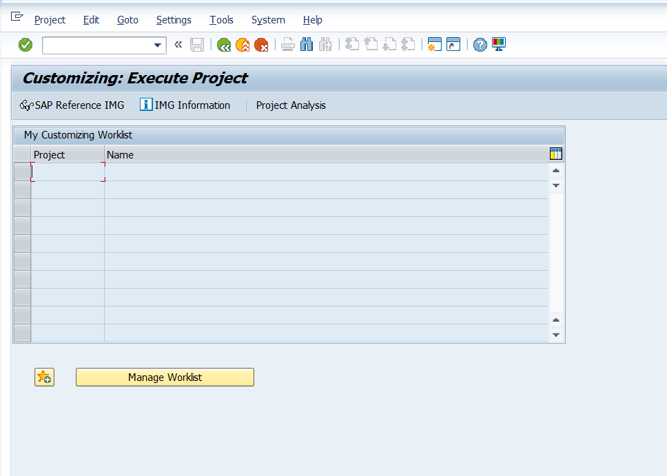
* Select Activity  
  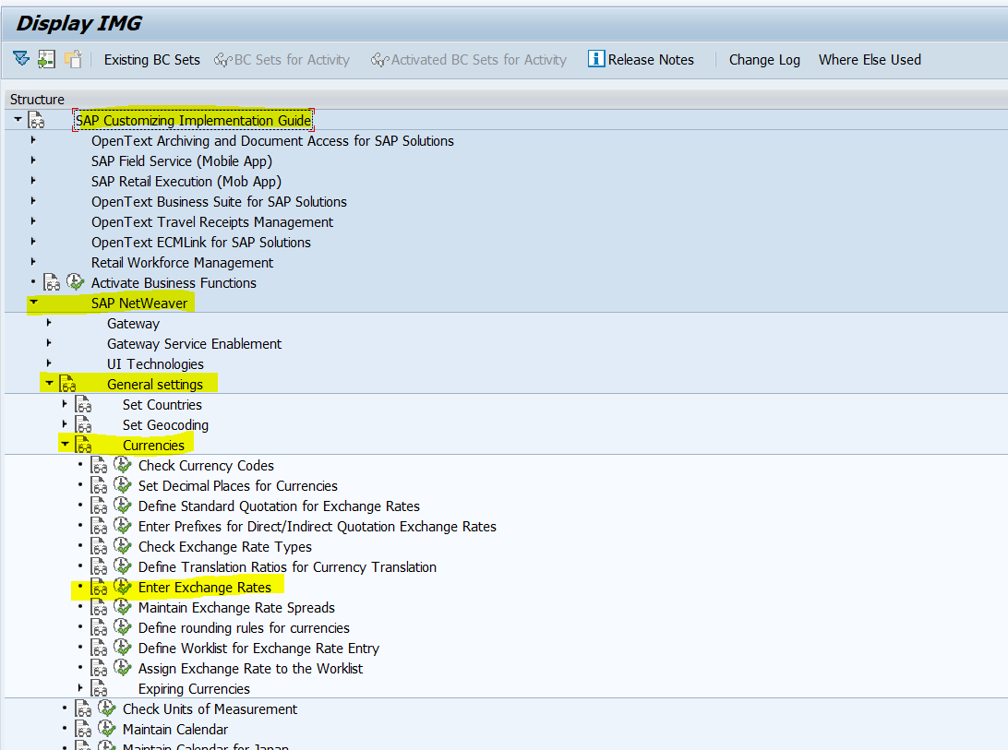
* Maintain currency  
  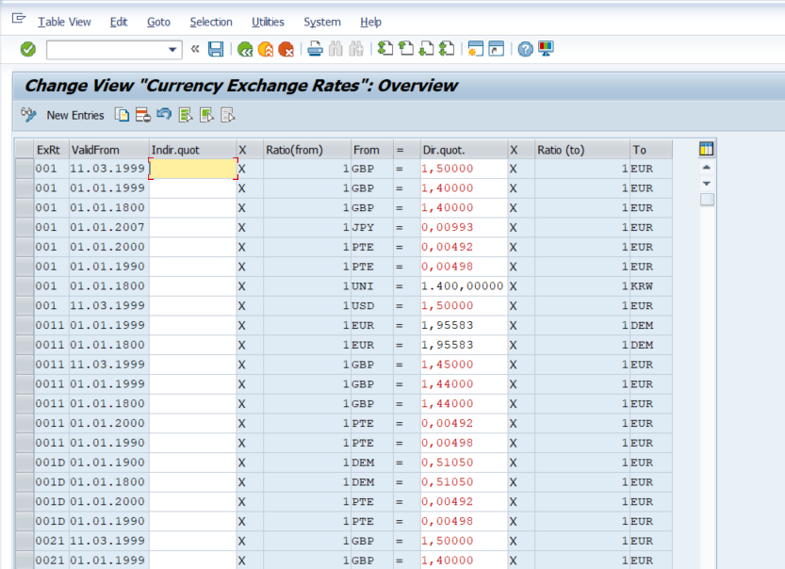

# Create custom extractor ZTCURR_ATTR

* This custom extractor is used to provide currencies for the data warehouse
* The extractor is ‘delta enabled’
* Use transaction RSO2

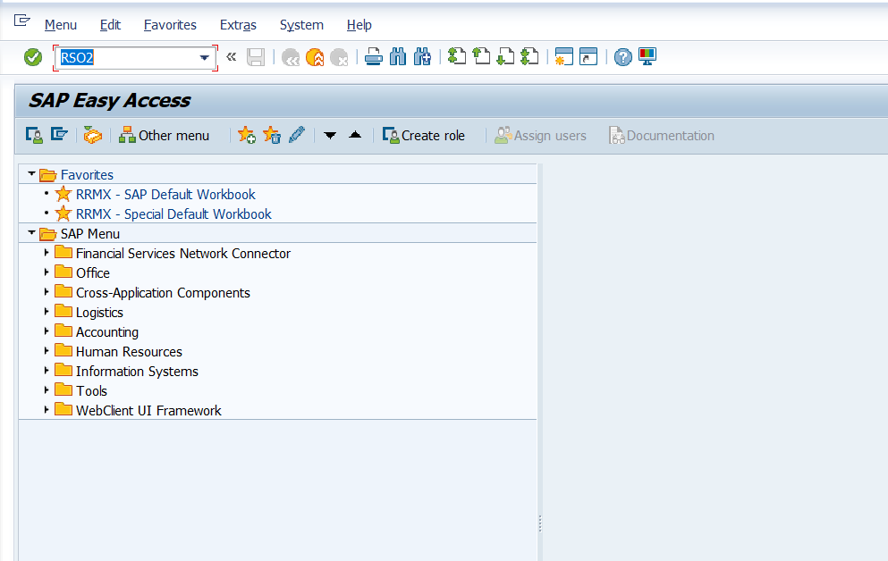

* Select ‘Transaction data’ – enter ZTCURR_ATTR – click ‘Create’

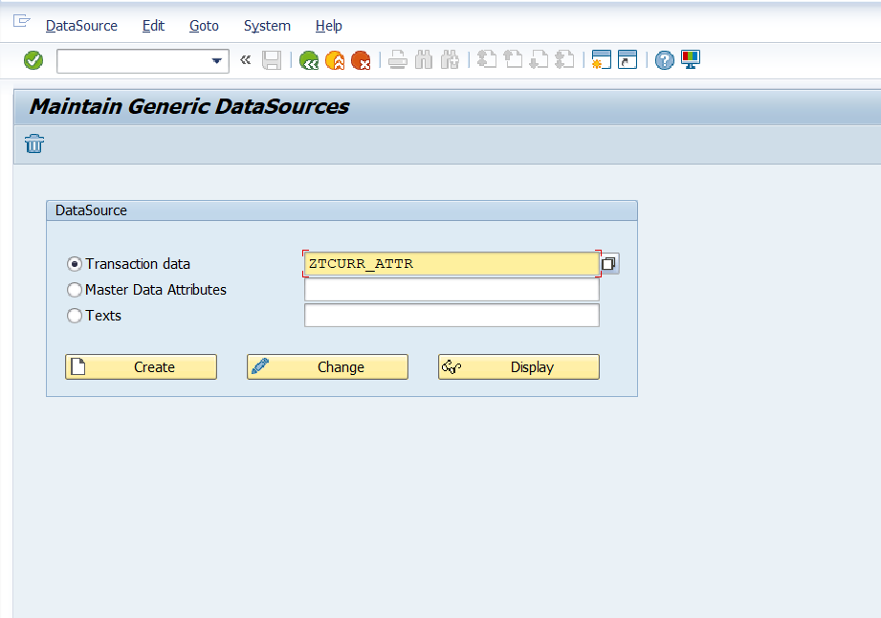

* Define Application Component – fill out fields as below

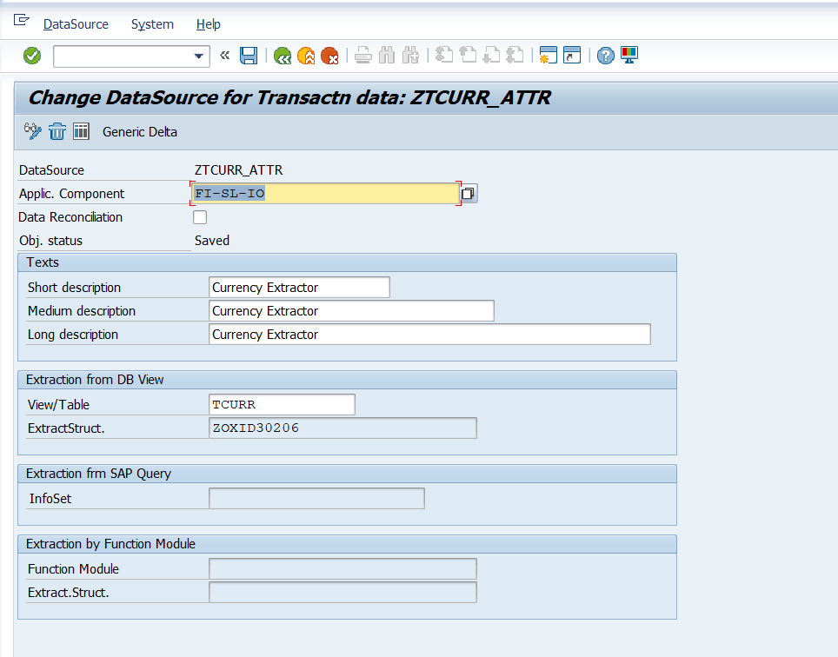

* Click Save – ‘click Generic Delta’ – fill out fields as below – click ‘Save’

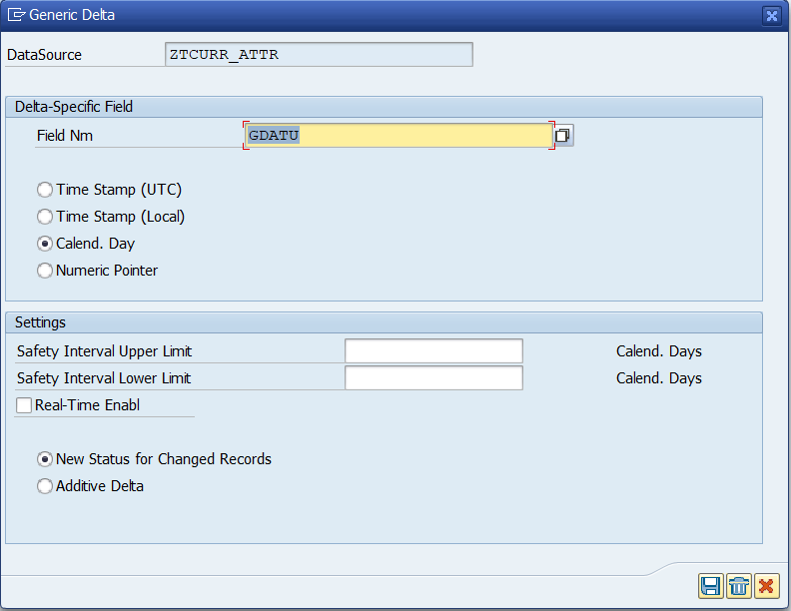

Test extractor ‘ZTCURR_ATTR’

* Use transaction RSA3

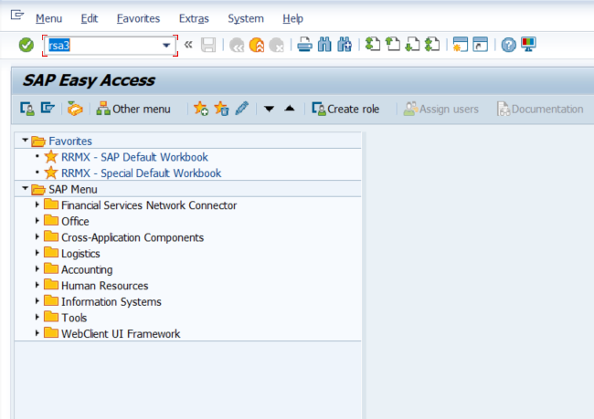

* Fill out fields as below – click ‘Extraction’

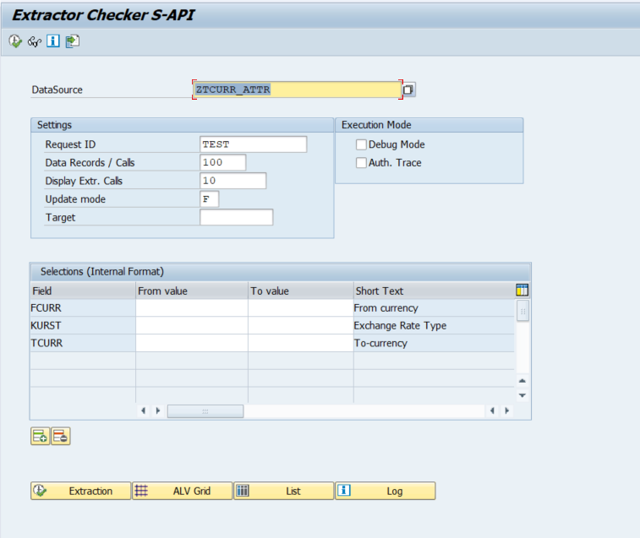

* Verify results – click on ‘ALV Grid’

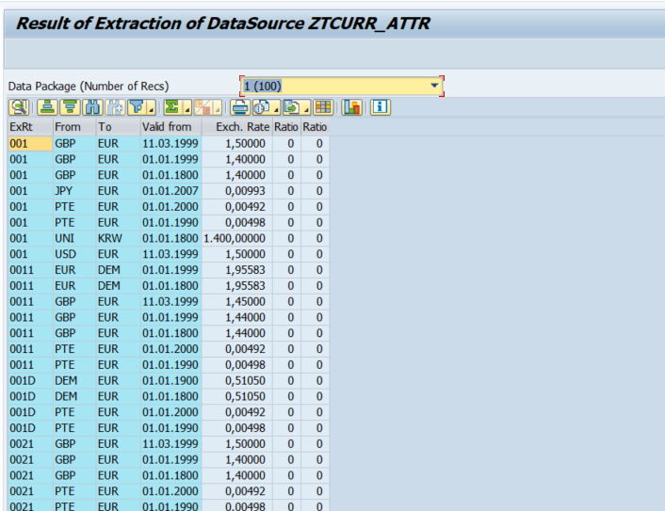



© 2020 QlikTech International AB. All rights reserved. All company and/or product names may be trade names, trademarks and/or registered trademarks of the respective owners with which they are associated.

**About Qlik**

Qlik’s vision is a data-literate world, one where everyone can use data to improve decision-making and solve their most challenging problems. Only Qlik offers end-to-end, real-time data integration and analytics solutions that help organizations access and transform all their data into value. Qlik helps companies lead with data to see more deeply into customer behavior, reinvent business processes, discover new revenue streams, and balance risk and reward. Qlik does business in more than 100 countries and serves over 50,000 customers around the world.

**qlik.com**



1. ZTCURR is a Custom Extractor. SAP Extractors typically starts with a number or ‘/’